ATSA – Montreal, QC.

September 18th – October 17th, 2009
Opening Reception: Friday, September 18th, 8pm – 10 pm
Artist Talk: Friday, September 18th at 7pm.
Common Weal: Prince Albert: September 19th at 1:30pm.
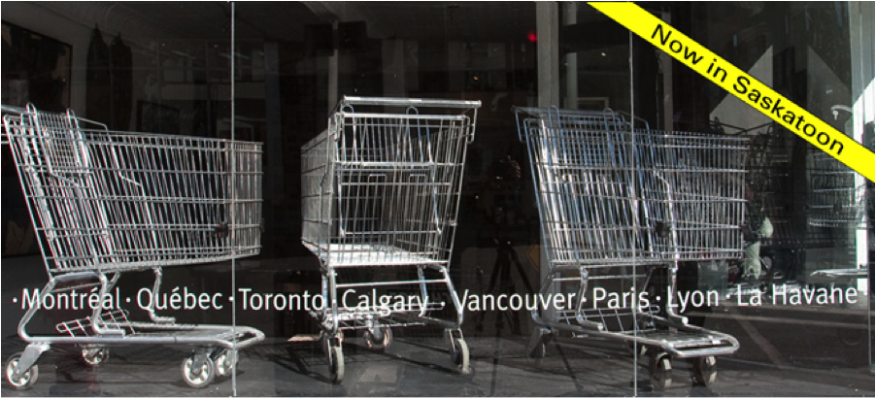
PAVED Arts, in collaboration with Commonweal (Prince Albert), proudly presents the 10 year retrospective project CHANGE by the Montreal-based collective ATSA.
What is CHANGE?
To celebrate its 10 years of existence, ATSA has immersed itself in the marketing universe, becoming a willing guinea pig for the opening of a temporary “pop-up shop” named CHANGE. ATSA has drawn from its photo archives and artifacts to create works and message-based tie-in merchandise, which are offered for sale to the general public. The exhibition CHANGE will make use of an artist-run space, disguised as a commercial shop, and will thereby act as a mechanism for fostering encounters and discussions on art. All works and derivative products reflect the issues broached by ATSA through its various interventions, and seek to introduce the collective to a new audience while reopening debates and lending the interventions a certain posterity. Rounding off the retrospective is a limited-edition, bilingual, 400-page publication available in 1,000 numbered copies. Titled ATSA: When Art Takes Action, the volume combines colour photographs, descriptions of works, a timeline, an interview with the artists, plus original texts by 11 theorists who, each in their respective field, share their insights on the social, environmental and heritage issues informing ATSA’s works.
What is ATSA?
ATSA is a not-for-profit organization founded in 1997 by artists Pierre Allard and Annie Roy. Its urban interventions—installations, maneuvers, realistic stagings—are intended to raise awareness of the social, environmental and cultural aberrations which preoccupy the two artists. ATSA’s works investigate and transform the urban landscape and restore the citizen’s place in the public realm, depicting it as a political space open to discussion and societal debates. ATSA is the recipient of the 2008 Artistes pour la Paix (artists for peace) prize and the 2008 Prix citoyen de la culture (cultural citizen award) handed out by organizations Artistes pour la Paix and Les Arts et la Ville, respectively.
To find out more, visit http://www.atsa.qc.ca/projs/change/magasin-uk.html.
Gallery Hours: Tuesday – Friday, Noon – 6 pm; Saturdays Noon – 4pm.
PAVED Arts acknowledges the support of our members, volunteers and partners, and of our principal funders: Canada Council for the Arts, Saskatchewan Arts Board, SaskCulture, SaskLotteries, the City of Saskatoon and the National Film Board of Canada.
For more information, contact: David LaRiviere, Artistic Director, tel. (306) 652-5502 ext.1 artistic@pavedarts.ca
PAVED Arts: 424 20th Street West Saskatoon SK. S7M 0X4 www.pavedarts.ca
Free admission to the public with barrier-free accessibility.

